Exercise 1. Look and write the missing letters

|  |  |  |  |
| --- | --- | --- | --- |
|  |  |  |  |
| Ball_ _n | p_nc_l | f_sh | P_pp_t |
|  |  |  |  |
| r_b_t | H_t | Tedd_ be_r | C_ayon |

Exercise 2. Match the letters to the correct pictures.

A B C D E F G H I

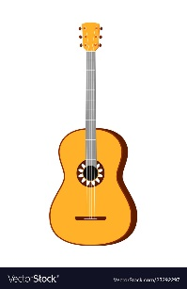  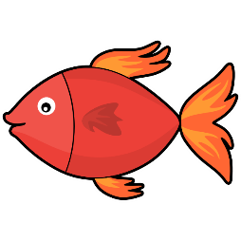 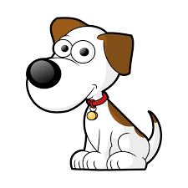 

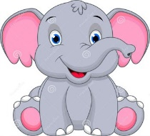 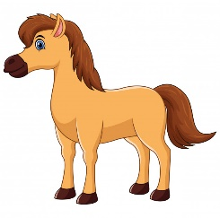 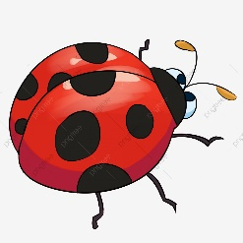 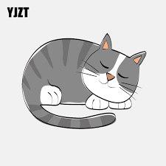

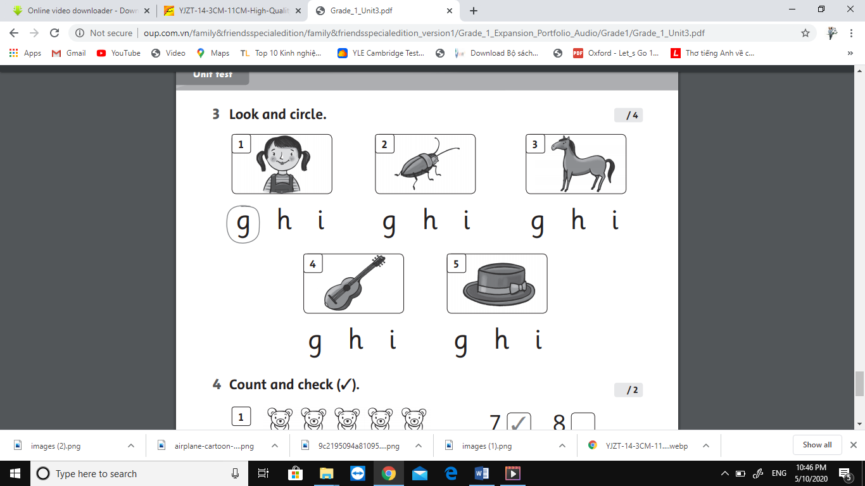

Exercise 4. Count and check :

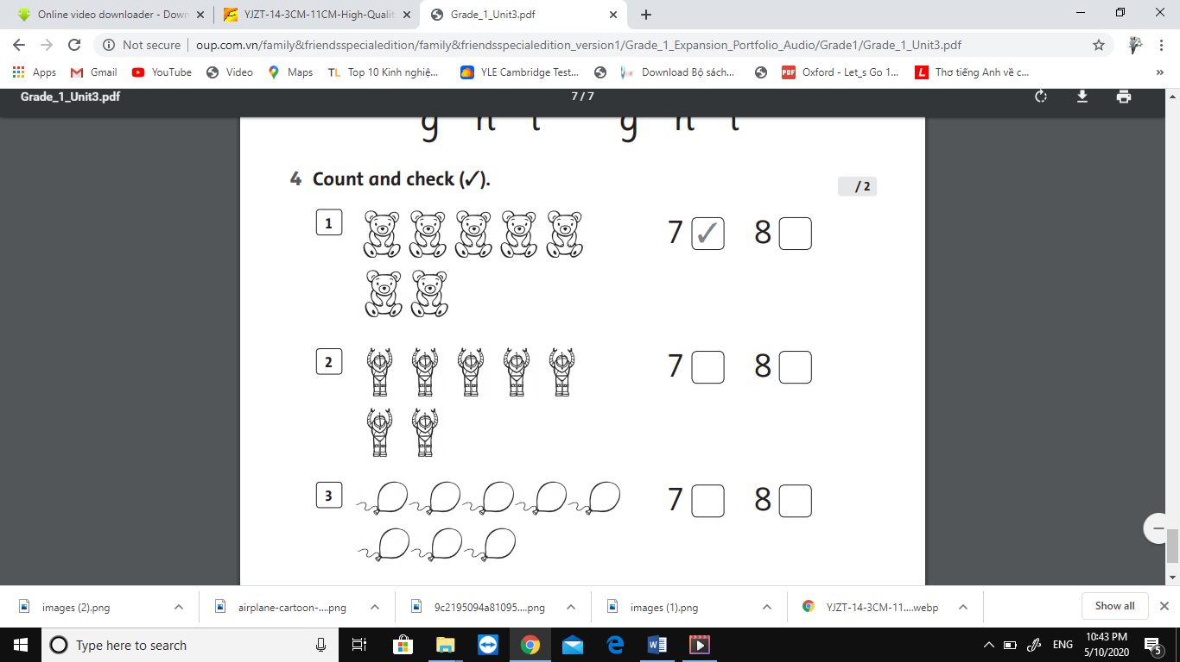

Exercise 5. Look and write

|  |  |
| --- | --- |
| Yes, it is. | No , it isn’t. |

|  |  |  |
| --- | --- | --- |
|  |  |  |
| 1. Is it a chair ? | 1. Is it a girl ? | 1. Is it a robot ? |
| *……………………………* | *……………………………* | *……………………………* |